
NATIONAL UNIVERSITY OF COMPUTER AND EMERGING SCIENCES
[KARACHI CAMPUS]
FAST School of Computing Spring 2025

DLD Project Report

SMART ATTENDANCE SYSTEM

Department:
BSCS
Date of submission: Members: 09-05-2025
Yash Raj Submitted to:
Fareeha Jabeen

1. Introduction
Manual attendance systems are often inefficient, prone to errors, and time-consuming. To address these challenges, this project proposes a Smart Attendance System that leverages RFID technology for identification and Bluetooth communication (HC-05) for real-time, wireless data transmission to mobile devices. This system aims to be cost-effective, reliable, and easy to implement.

2. Objective
The main objectives of this project are:
- To design a contactless attendance system using RFID and Bluetooth.
- To transmit attendance data wirelessly to a mobile device.
- To minimize errors caused by manual attendance taking.
- To enable real-time recording of attendance with possibilities for future integration into broader systems like HR, academic records, or event management platforms.

3. System Overview
The Smart Attendance System functions by using an RFID reader (RC522) to scan individual RFID cards/tags. Each card contains a Unique Identifier (UID). The Arduino Uno reads this UID and sends it over Bluetooth (HC-05 module) to a paired mobile device. The mobile device then logs or processes the received UID data.

Key Features:
- Contactless scanning.
- Wireless transmission to mobile.
- Real-time attendance logging.
- Portable and energy-efficient design.

4. Components Used
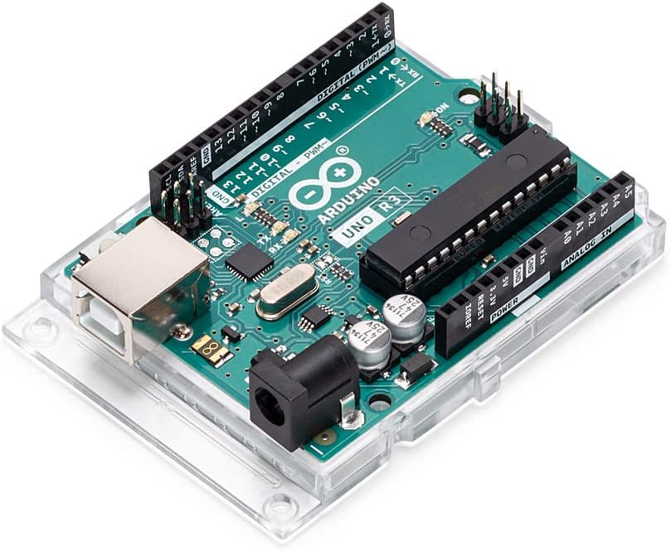

4.1 Arduino Uno
- Serves as the central controller of the system.
- Reads data from the RFID reader.
- Sends the UID to the HC-05 Bluetooth module using UART communication.
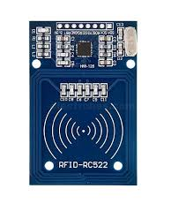

4.2 RFID Module (RC522)
- Reads RFID cards/tags.
- Communicates with Arduino via SPI (Serial Peripheral Interface).
- Each card/tag has a unique UID that identifies a user.

4.3 RFID Tags/Cards
- Carry a pre-programmed UID.
- Represent individual users (students, employees, participants, etc.).

4.4 HC-05 Bluetooth Module
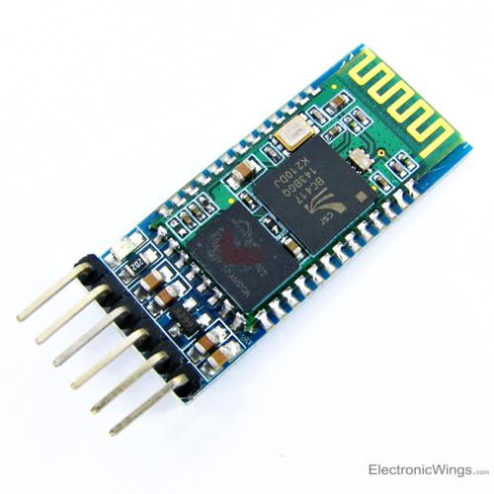
- Transmits UID data to a paired mobile device wirelessly.
- Operates on UART (serial communication with Arduino).

4.5 Mobile Device (Android/iOS)
- Receives and logs/display UID data.
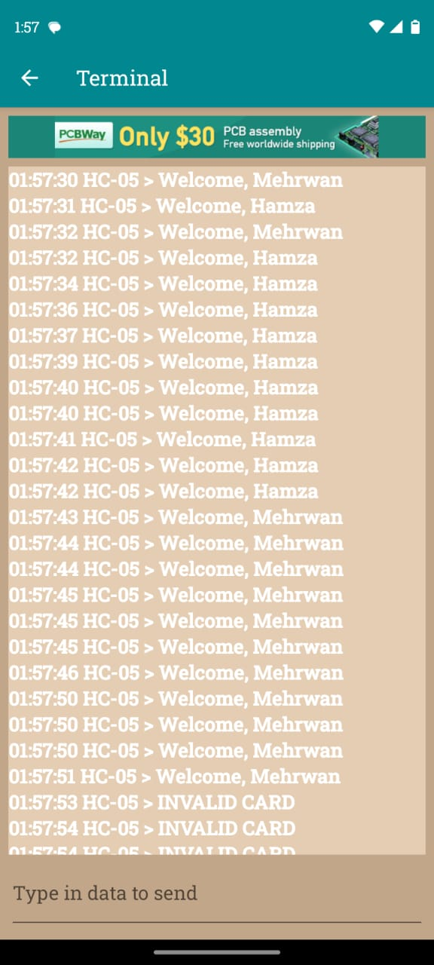
- Can use a Bluetooth terminal app or a custom-developed app for attendance management.

4.6 Power Supply
- System can be powered via USB connection or a portable battery pack for mobility.

5. System Connectivity and Data Flow

5.1 System Diagram:
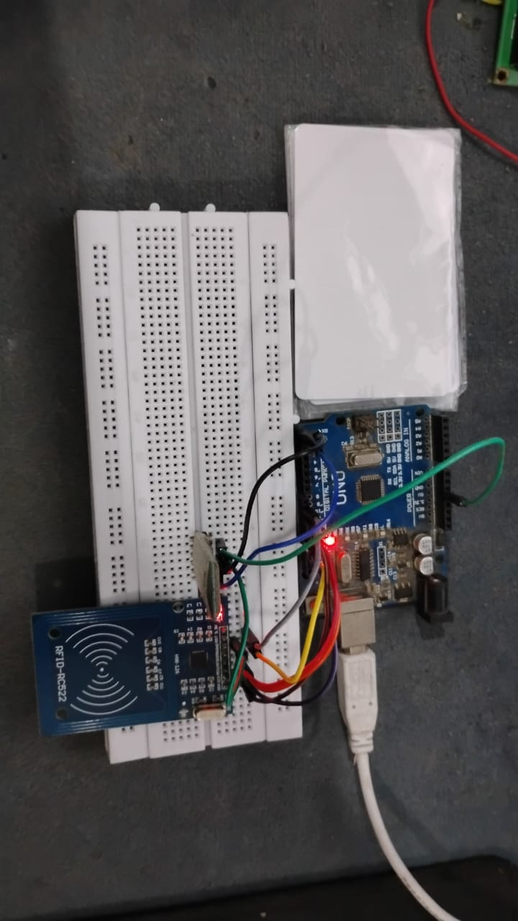

5.2 Step-by-Step Working
- User taps the RFID card/tag on the RC522 reader.
- RC522 module reads the UID of the card.
- Arduino processes the UID and sends it through serial communication to the HC-05 Bluetooth module.
- HC-05 module transmits the UID wirelessly.
- Mobile device receives the UID and logs/displays the attendance information.

6. UID Usage
- Each RFID card has a hardcoded UID (example: 73 22 4A B3).
- The system can either:
  - Compare the UID against a predefined database in Arduino, or
  - Send the UID directly to the mobile device for processing.
- UID ensures unique identification for each individual, preventing errors like proxy attendance.

7. Arduino Source Code
Below is the core Arduino code used to interface the RFID module with the Arduino Uno and identify users based on hardcoded UIDs: 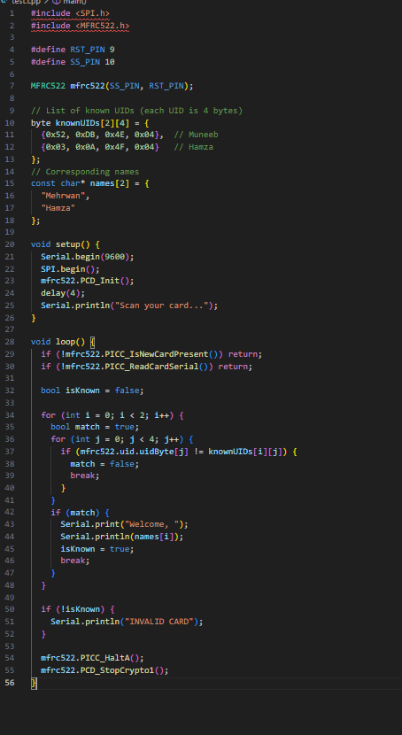
This code can be compiled using arduino ide.

Code Explanation
- Libraries Used: SPI.h for SPI communication and MFRC522.h for RFID functionality.
- UID Matching: The code compares the scanned UID with a list of predefined UIDs stored in a 2D array.
- User Identification: If a match is found, a welcome message with the corresponding name is printed to the Serial Monitor.
- Fallback Message: If no match is found, it prints "INVALID CARD".

Significance
- This method allows for a simple and quick identification of users.
- It is ideal for small-scale implementations where only a limited number of RFID cards are used.
- For larger deployments, future versions of the system could fetch UIDs dynamically from external storage or a cloud database.

8. Advantages of the Project
- Contactless and hygienic attendance system.
- Wireless transmission reduces wiring complexity.
- Portable and easy to deploy.
- Cost-effective compared to commercial biometric solutions.
- Minimizes human errors and eliminates need for paper records.
- Scalable for future integration with cloud services, notifications, and backend databases.

9. Future Enhancements
- Add a Real-Time Clock (RTC) module to log time and date with each UID.
- Store data locally on a microSD card or sync with a cloud database.
- Develop a dedicated mobile app for better user experience and attendance reporting.
- Display student/employee name and entry time on an LCD or OLED screen after scan.
- Add LED indicators or buzzers for feedback on successful scans.
- Enable automatic notifications (e.g., SMS/email alerts) for absences or late entries.

